**Exercise 1: Implementing the Singleton Pattern**

Code,

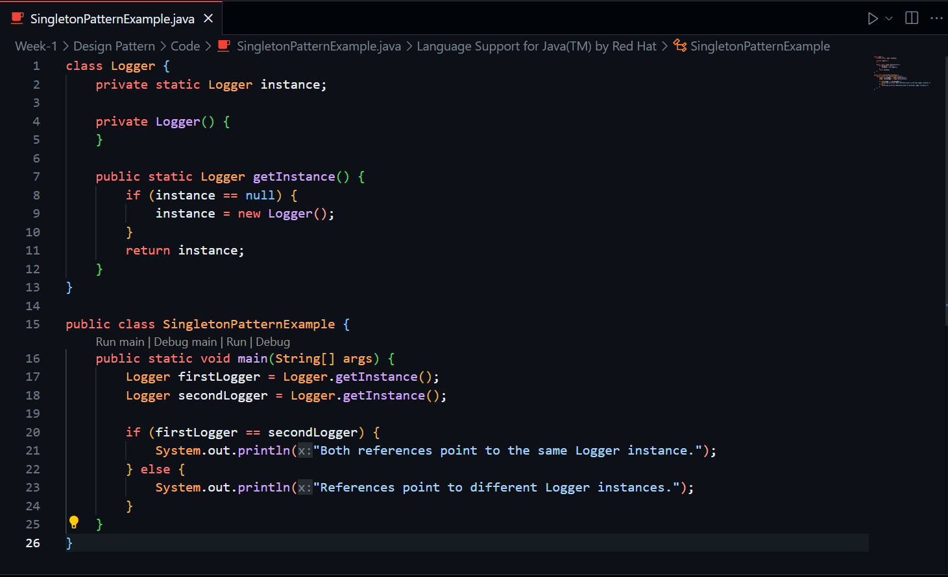

Output,

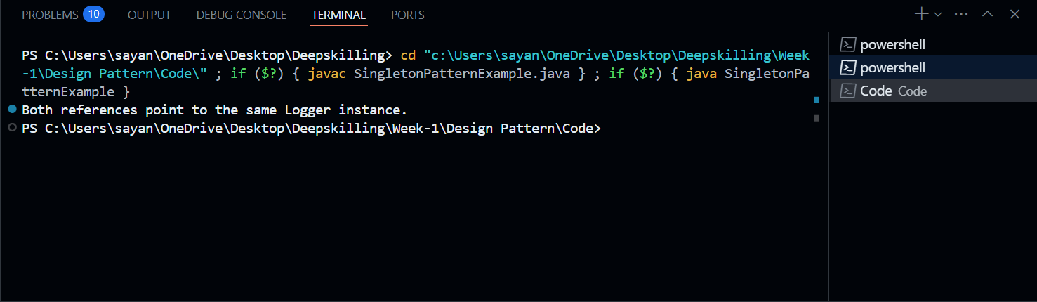

**Exercise 2: Implementing the Factory Method Pattern**

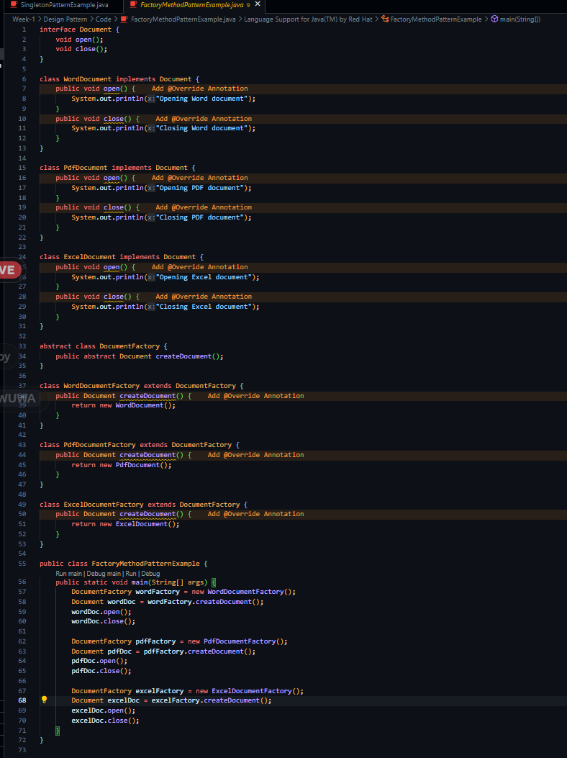Code,

Output,

